Container Dashboard



DATDRD05-T08

Jasper van Woudenberg

1674469

Oliver Ntenje

Contents

Summary YouTube video 3

Business understanding 4

**Objective:** 4

**Scope and Impact:** 4

Data understanding & Data Preperation: 4

Modeling & Evaluation: 5

Deployment: 5

Self-Reflection: 7

Bibliography 9

Appendix 1: HTML code. 10

Appendix 2: Powerpoint Presentation 30

# Summary YouTube video

Link to the YouTube video: <https://www.youtube.com/watch?v=E9_pPwZdUXI>

In this video the presenter begins by outlining the supply chain's structure and emphasizes the importance of accurate demand forecasting.

Key factors influencing demand are discussed, including:

* **Seasonality**: Regular patterns or fluctuations in demand corresponding to seasons or specific time periods.
* **Trends**: Long-term movements indicating an increase or decrease in demand over time.
* **External Factors**: Variables such as economic conditions, competitor actions, and market dynamics that can impact demand.

The video delves into time series features, highlighting their significance in capturing temporal patterns essential for forecasting.

The presenter introduces machine learning models suitable for demand forecasting, such as:

* **Linear Regression**: A statistical method for modeling the relationship between a dependent variable and one or more independent variables.
* **Decision Trees**: A model that uses a tree-like graph of decisions and their possible consequences.
* **Neural Networks**: Computing systems inspired by biological neural networks, capable of pattern recognition and predictive modeling.

The process of training these models is explained, emphasizing the importance of data preparation, feature selection, and model evaluation to ensure accurate predictions.

The video also addresses potential challenges in demand forecasting, such as data quality issues, changing market conditions, and the need for continuous model updates to maintain accuracy. In summary, the video serves as an informative resource for understanding how machine learning can enhance demand forecasting, thereby improving decision-making and efficiency in supply chain management.

# Business understanding

In the skip and waste management industry predictions are scarce. The use of proper dashboarding does not take place nearly as much as possible. That is what inspired me to create this dashboard with a prediction.

## Objective:

The primary aim is to develop a dashboard integrated with a predictive model that identifies which containers are most likely to be ordered. This tool is designed to enable stakeholders to make informed decisions efficiently and effectively.

## Scope and Impact:

The dashboard will provide actionable insights into container demand trends, improving operational efficiency and reducing potential stock management issues. The prediction model adds value by reducing reliance on manual forecasts.

# Data understanding & Data Preperation:

Create Dataset:

Due to the confidentiality of customer names and project addresses. It is no easy task to find and use a database online. For this reason, a database must be created. This was done by Artificial intelligence. For AI to successfully create a database it needs columns to fill.

For this project the following columns were generated:

* Date: From January 1st, 2023, until December 31st 2024.
* Day: Type of day, ex: Monday, Tuesday, Wednesday etc.
* City: Name of the city in the Netherlands where the container has been placed. Previously it had been tried to use postal codes. Unfortunately, there has not been a successful way to implement this.
* Container: The size of the container. The possibilities are :10m3, 6m3 and 3m3.
* Customer name: The name of the customer.
* Number of containers: The number of containers for a single project at the same time.

While making this dataset it was overseen that it should be in Englisch instead of Dutch. Because this went unnoticed the dataset and column names are in Dutch

Due to the database being made for the sole purpose of testing the dashboard no further actions in regard to checking the quality have been taken.

# Modeling & Evaluation:

The next steps in the CRISP-DM model are the modeling and evaluation part. With the deliverable being a dashboard constant evaluation after changes are made. This means that with every change the added value is evaluated.

# Deployment:

The last step is deployment.

The dataset which was used to create the visualization is in the github repositorie.

The used code is attached in Appendix 1.

Figure 1 is a screenshot of how the dashboard looks raw, when uploading a dataset it changes. The presentation about this project with multiple screenshots is in appendix 2.

The desired functionality of this dashboard shows the statistics from the database within the filtered dates. It should also show the predictions regarding the selected date based on the inserted CSV database. However, this functionality is not operational unfortunately.

Another functionality within this dashboard is a map. This is showed in figure 2. On this maps data point are visible as dots. With the bigger the dot the more containers have been ordered in that city.

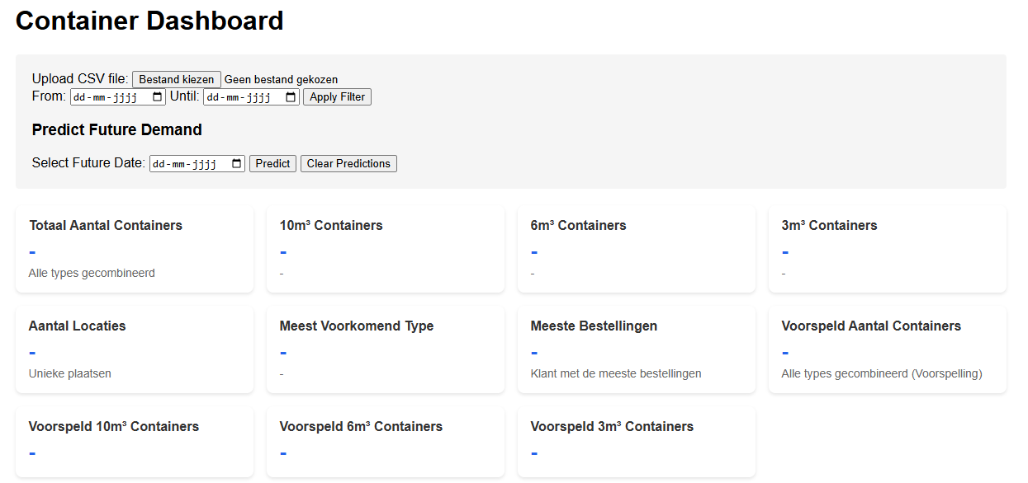

Figure , Dashboard without uploaded data

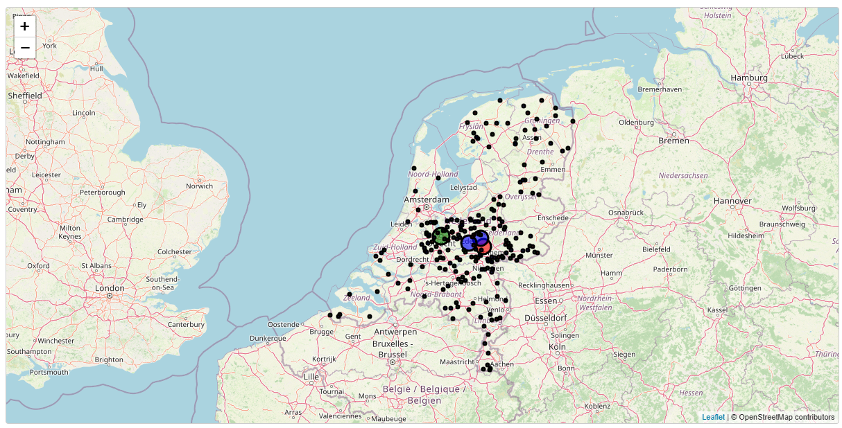

Figure Map of containers

# Self-Reflection:

To reflect on this project the reflection spiral of Korthagen (Ben, 2023) has been applied.

**Step 1: Action**

I aimed to develop a web-based dashboard with a regression model that could process uploaded CSV files to predict the expected outcome of future dates directly.

**Step 2: Looking Back**

Unfortunately, the project did not go as planned. The dashboard lacked the desired functionality because the regression model could not be implemented without backend support. And to perform an accurate prediction a regression model is an excellent method. I realized that a Python backend code was necessary for processing the data and generating the predictions. An API would solve this problem, however i struggled to implement this effectively.

The deliverable turned out to be a simple dashboard with an even simpler prediction model which uses math to predict the demand, and does not work most of the times.

**Step 3: Awareness**

This experience has made me aware of my limitations in understanding API integration and backend development. I underestimated the technical complexity of achieving this functionality in a purely web-based environment. The absence of a backend approach hindered the success of the project.

**Step 4: Alternatives**

To address these challenges, I could explore several alternatives:

* Deepening my understanding of API design and backend development in Python.
* Seeking collaboration with classmates experienced in backend integration.
* Using existing tools or frameworks that simplify API implementation for data processing.
* Modifying the scope of the project to match my current expertise and tools.

**Step 5: Trial**

In my next attempt, I plan to start small by building a simple Python-based backend that can handle CSV uploads and perform regression analysis. Once this works independently, I’ll integrate it with the web-based dashboard step by step. Additionally, I will dedicate time to learning API structures and backend frameworks like Flask or FastAPI to build my skills systematically.

# Bibliography

Ben, J. (2023, May 18). *Toolshero- Personal Development- Korthagen reflection model*. Opgeroepen op January 7, 2025, van Toolshero: https://www.toolshero.com/personal-development/korthagen-reflection-model/

# Appendix 1: HTML code.

<!DOCTYPE html>

<html lang="en">

<head>

    <meta charset="UTF-8">

    <meta name="viewport" content="width=device-width, initial-scale=1.0">

    <title>Container Dashboard</title>

    <link rel="stylesheet" href="https://cdnjs.cloudflare.com/ajax/libs/leaflet/1.7.1/leaflet.css" />

    <style>

        body {

            margin: 0;

            padding: 20px;

            font-family: Arial, sans-serif;

        }

        .container {

            max-width: 1200px;

            margin: 0 auto;

        }

        #map {

            height: 600px;

            width: 100%;

            margin-top: 20px;

            border: 1px solid #ccc;

            border-radius: 4px;

        }

        .controls {

            margin: 20px 0;

            padding: 20px;

            background-color: #f5f5f5;

            border-radius: 4px;

        }

        .legend {

            padding: 10px;

            background: white;

            border-radius: 4px;

            border: 1px solid #ccc;

            margin-top: 10px;

            position: absolute;

            bottom: 30px;

            left: 30px;

            z-index: 1000;

        }

        .legend-item {

            margin: 5px 0;

            display: flex;

            align-items: center;

        }

        .legend-dot {

            width: 12px;

            height: 12px;

            border-radius: 50%;

            margin-right: 8px;

        }

        .stats-grid {

            display: grid;

            grid-template-columns: repeat(auto-fit, minmax(250px, 1fr));

            gap: 1rem;

            margin: 20px 0;

        }

        .stat-card {

            background: white;

            padding: 1rem;

            border-radius: 8px;

            box-shadow: 0 2px 4px rgba(0,0,0,0.1);

        }

        .stat-card h3 {

            margin: 0 0 0.5rem 0;

            color: #333;

            font-size: 1rem;

        }

        .stat-card p {

            margin: 0;

            font-size: 1.5rem;

            font-weight: bold;

            color: #2563eb;

        }

        .stat-card .secondary {

            font-size: 0.875rem;

            color: #666;

            margin-top: 0.25rem;

        }

    </style>

</head>

<body>

    <div class="container">

        <h1>Container Dashboard</h1>

        <div class="controls">

            <label for="csvFile">Upload CSV file:</label>

            <input type="file" id="csvFile" accept=".csv">

            <div>

                <label for="startDate">From:</label>

                <input type="date" id="startDate">

                <label for="endDate">Until:</label>

                <input type="date" id="endDate">

                <button id="filterButton">Apply Filter</button>

            </div>

            <div>

                <h3>Predict Future Demand</h3>

                <label for="futureDate">Select Future Date:</label>

                <input type="date" id="futureDate">

                <button id="predictButton">Predict</button>

                <button id="clearPredictionButton">Clear Predictions</button>

            </div>

        </div>

        <div class="stats-grid">

            <div class="stat-card">

                <h3>Total number of Containers</h3>

                <p id="totalContainers">-</p>

                <div class="secondary">All types combined</div>

            </div>

            <div class="stat-card">

                <h3>10m³ Containers</h3>

                <p id="total10m3">-</p>

                <div class="secondary" id="percentage10m3">-</div>

            </div>

            <div class="stat-card">

                <h3>6m³ Containers</h3>

                <p id="total6m3">-</p>

                <div class="secondary" id="percentage6m3">-</div>

            </div>

            <div class="stat-card">

                <h3>3m³ Containers</h3>

                <p id="total3m3">-</p>

                <div class="secondary" id="percentage3m3">-</div>

            </div>

            <div class="stat-card">

                <h3>Number of Locations</h3>

                <p id="totalLocations">-</p>

                <div class="secondary">Unique Locations</div>

            </div>

            <div class="stat-card">

                <h3>Mode Type</h3>

                <p id="mostCommonType">-</p>

                <div class="secondary" id="mostCommonTypePercentage">-</div>

            </div>

            <!-- Nieuwe Card voor Meeste Bestellingen -->

            <div class="stat-card">

                <h3>Most Orders Customers</h3>

                <p id="mostOrdersCustomer">-</p>

                <div class="secondary">Customer with the most orders</div>

            </div>

            <!-- Nieuwe Cards voor voorspelling -->

            <div class="stat-card">

                <h3>Predicted total Containers</h3>

                <p id="predictedTotalContainers">-</p>

                <div class="secondary">All types combined (Predictions)</div>

            </div>

            <div class="stat-card">

                <h3>Predicted 10m³ Containers</h3>

                <p id="predictedTotal10m3">-</p>

            </div>

            <div class="stat-card">

                <h3>Predicted 6m³ Containers</h3>

                <p id="predictedTotal6m3">-</p>

            </div>

            <div class="stat-card">

                <h3>Predicted 3m³ Containers</h3>

                <p id="predictedTotal3m3">-</p>

            </div>

        </div>

        <div id="map"></div>

        <div class="legend">

            <div class="legend-item">

                <span class="legend-dot" style="background-color: blue;"></span>

                10m³ Containers (Most Common)

            </div>

            <div class="legend-item">

                <span class="legend-dot" style="background-color: green;"></span>

                6m³ Containers (Most Common)

            </div>

            <div class="legend-item">

                <span class="legend-dot" style="background-color: red;"></span>

                3m³ Containers (Most Common)

            </div>

        </div>

    </div>

    <script src="https://cdnjs.cloudflare.com/ajax/libs/leaflet/1.7.1/leaflet.js"></script>

    <script src="https://cdnjs.cloudflare.com/ajax/libs/PapaParse/5.3.0/papaparse.min.js"></script>

    <script>

        let deliveryData = [];

        let predictionMarkers = [];

        let map;

        // Initialize map after DOM is loaded

        document.addEventListener('DOMContentLoaded', function() {

            map = L.map('map').setView([52.1326, 5.2913], 8);

            L.tileLayer('https://{s}.tile.openstreetmap.org/{z}/{x}/{y}.png', {

                attribution: '© OpenStreetMap contributors'

            }).addTo(map);

        });

        async function geocodePlace(place) {

            try {

                const formattedPlace = `${place}, Netherlands`;

                const url = `https://nominatim.openstreetmap.org/search?q=${encodeURIComponent(formattedPlace)}&format=json&limit=1`;

                const response = await fetch(url);

                const data = await response.json();

                if (data.length > 0) {

                    return { lat: parseFloat(data[0].lat), lng: parseFloat(data[0].lon) };

                }

                return { lat: 52.1326, lng: 5.2913 }; // Default to central Netherlands

            } catch {

                return { lat: 52.1326, lng: 5.2913 };

            }

        }

        function getMostCommonContainerType(containers) {

            let maxCount = 0;

            let mostCommonType = null;

            for (const [type, count] of Object.entries(containers)) {

                if (count > maxCount) {

                    maxCount = count;

                    mostCommonType = type;

                }

            }

            return mostCommonType;

        }

        function getMarkerColor(containerType) {

            if (containerType === '10m3') return 'blue';

            if (containerType === '6m3') return 'green';

            if (containerType === '3m3') return 'red';

            return 'gray';

        }

        function createPopupContent(place, containers, total, mostCommonType) {

            let content = `Plaats: ${place}\n`;

            content += `Meest voorkomend: ${mostCommonType}\n`;

            content += `Totaal: ${total}\n`;

            // Define fixed order of container types

            const containerOrder = ['10m3', '6m3', '3m3'];

            // Add container counts in fixed order

            containerOrder.forEach(type => {

                if (type in containers) {

                    content += `${type}: ${containers[type]}\n`;

                } else {

                    content += `${type}: 0\n`;

                }

            });

            // Replace newlines with <br> for HTML display

            return content.split('\n').filter(line => line).join('<br>');

        }

        function getCustomerWithMostOrders(filteredData) {

            const customerOrders = {};

            // Telt het aantal bestellingen per klant

            filteredData.forEach(row => {

                const customer = row.Klantnaam?.trim();

                const orderCount = 1; // Elke rij vertegenwoordigt een bestelling

                if (!customer) return;

                if (!customerOrders[customer]) {

                    customerOrders[customer] = 0;

                }

                customerOrders[customer] += orderCount;

            });

            // Zoek de klant met de meeste bestellingen

            let maxOrders = 0;

            let mostOrdersCustomer = null;

            for (const [customer, orderCount] of Object.entries(customerOrders)) {

                if (orderCount > maxOrders) {

                    maxOrders = orderCount;

                    mostOrdersCustomer = customer;

                }

            }

            return mostOrdersCustomer;

        }

        function updateStatistics(filteredData, predictedData = null) {

            // Initialize counters

            let total = 0;

            let total10m3 = 0;

            let total6m3 = 0;

            let total3m3 = 0;

            const uniqueLocations = new Set();

            // Calculate totals

            filteredData.forEach(row => {

                const count = parseInt(row['Number of Containers']) || 0;

                const type = row.Container?.trim();

                const place = row.Plaats?.trim();

                if (place) uniqueLocations.add(place);

                total += count;

                if (type === '10m3') total10m3 += count;

                if (type === '6m3') total6m3 += count;

                if (type === '3m3') total3m3 += count;

            });

            // Calculate percentages

            const percentage10m3 = ((total10m3 / total) * 100).toFixed(1);

            const percentage6m3 = ((total6m3 / total) * 100).toFixed(1);

            const percentage3m3 = ((total3m3 / total) * 100).toFixed(1);

            // Determine most common type

            const typeCount = [

                { type: '10m3', count: total10m3 },

                { type: '6m3', count: total6m3 },

                { type: '3m3', count: total3m3 }

            ];

            const mostCommon = typeCount.reduce((prev, current) =>

                (prev.count > current.count) ? prev : current

            );

            // Get the customer with the most orders

            const mostOrdersCustomer = getCustomerWithMostOrders(filteredData);

            // Update UI

            document.getElementById('totalContainers').textContent = total.toLocaleString();

            document.getElementById('total10m3').textContent = total10m3.toLocaleString();

            document.getElementById('total6m3').textContent = total6m3.toLocaleString();

            document.getElementById('total3m3').textContent = total3m3.toLocaleString();

            document.getElementById('totalLocations').textContent = uniqueLocations.size.toLocaleString();

            document.getElementById('mostCommonType').textContent = mostCommon.type;

            document.getElementById('percentage10m3').textContent = `${percentage10m3}% of total`;

            document.getElementById('percentage6m3').textContent = `${percentage6m3}% of total`;

            document.getElementById('percentage3m3').textContent = `${percentage3m3}% of total`;

            document.getElementById('mostCommonTypePercentage').textContent =

                `${((mostCommon.count / total) * 100).toFixed(1)}% of total`;

            // Update the most orders customer card

            document.getElementById('mostOrdersCustomer').textContent = mostOrdersCustomer || '-';

            // Display predicted statistics for the selected future date

            if (predictedData) {

                let predictedTotal = 0;

                let predicted10m3 = 0;

                let predicted6m3 = 0;

                let predicted3m3 = 0;

                predictedData.forEach(row => {

                    const predictedCount = parseInt(row['Number of Containers']) || 0;

                    const type = row.Container?.trim();

                    predictedTotal += predictedCount;

                    if (type === '10m3') predicted10m3 += predictedCount;

                    if (type === '6m3') predicted6m3 += predictedCount;

                    if (type === '3m3') predicted3m3 += predictedCount;

                });

                // Update predicted statistics in the UI

                document.getElementById('predictedTotalContainers').textContent = predictedTotal.toLocaleString();

                document.getElementById('predictedTotal10m3').textContent = predicted10m3.toLocaleString();

                document.getElementById('predictedTotal6m3').textContent = predicted6m3.toLocaleString();

                document.getElementById('predictedTotal3m3').textContent = predicted3m3.toLocaleString();

            }

        }

        async function addMarkers(data) {

            // Clear existing markers

            map.eachLayer(layer => {

                if (layer instanceof L.CircleMarker) {

                    map.removeLayer(layer);

                }

            });

            const placeTotals = {};

            data.forEach(row => {

                const place = row.Plaats?.trim();

                const containerCount = parseInt(row['Number of Containers']);

                const containerType = row.Container?.trim();

                if (!place || isNaN(containerCount) || !containerType) return;

                if (!placeTotals[place]) {

                    placeTotals[place] = { total: 0, containers: {} };

                }

                placeTotals[place].total += containerCount;

                if (!placeTotals[place].containers[containerType]) {

                    placeTotals[place].containers[containerType] = 0;

                }

                placeTotals[place].containers[containerType] += containerCount;

            });

            for (const [place, { total, containers }] of Object.entries(placeTotals)) {

                const coordinates = await geocodePlace(place);

                const radius = Math.sqrt(total) * 1.5;

                const mostCommonType = getMostCommonContainerType(containers);

                const markerColor = getMarkerColor(mostCommonType);

                const marker = L.circleMarker([coordinates.lat, coordinates.lng], {

                    color: 'black',

                    fillColor: markerColor,

                    radius: radius,

                    fillOpacity: 0.6

                }).addTo(map);

                const popupContent = createPopupContent(place, containers, total, mostCommonType);

                marker.bindPopup(popupContent);

            }

        }

        function updateMap() {

            const startDate = document.getElementById('startDate').value;

            const endDate = document.getElementById('endDate').value;

            const futureDate = document.getElementById('futureDate').value;  // Get the future date

            if (!startDate && !endDate && !futureDate) {

                alert("Please select at least one date filter.");

                return;

            }

            const filteredData = deliveryData.filter(row => {

                if (!row.Datum) return false;

                const date = new Date(row.Datum);

                if (isNaN(date.getTime())) {

                    console.warn(`Invalid date format in row: ${row.Datum}`);

                    return false;

                }

                const start = startDate ? new Date(startDate) : null;

                const end = endDate ? new Date(endDate) : null;

                return (!start || date >= start) && (!end || date <= end);

            });

            // Now get predicted data for the selected future date

            let predictedData = [];

            if (futureDate) {

                predictedData = deliveryData.filter(row => {

                    const date = new Date(row.Datum);

                    return date.toISOString().split('T')[0] === futureDate;  // Matching the future date

                });

            }

            updateStatistics(filteredData, predictedData);

            addMarkers(filteredData);

        }

        // Event Listeners

        document.getElementById('filterButton').addEventListener('click', updateMap);

        document.getElementById('csvFile').addEventListener('change', (e) => {

            const file = e.target.files[0];

            if (!file) return;

            Papa.parse(file, {

                header: true,

                skipEmptyLines: true,

                complete: function(results) {

                    deliveryData = results.data;

                    updateMap();

                }

            });

        });

        document.getElementById('clearPredictionButton').addEventListener('click', () => {

            predictionMarkers.forEach(marker => {

                map.removeLayer(marker);

            });

            predictionMarkers = [];

        });

    </script>

</body>

</html>

# Appendix 2: Powerpoint Presentation

